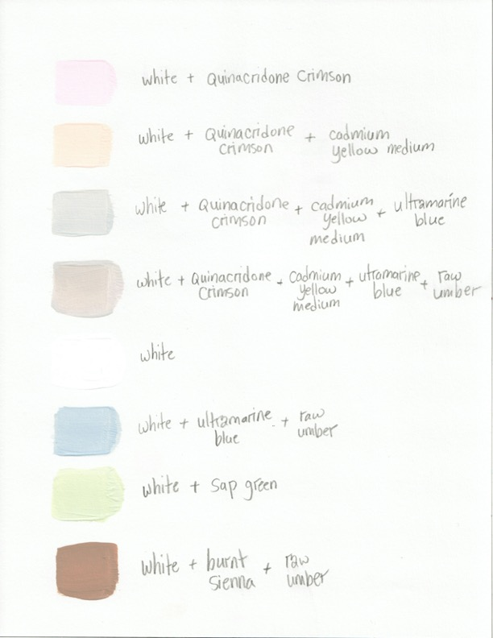

Birch Studies, *Color Mixing*